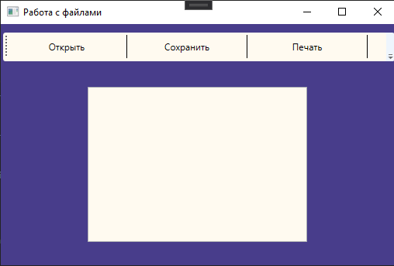

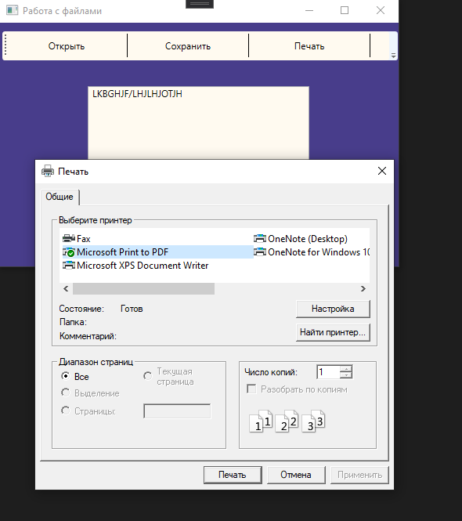

<Window x:Class="lebedevaPr5.MainWindow"

xmlns="http://schemas.microsoft.com/winfx/2006/xaml/presentation"

xmlns:x="http://schemas.microsoft.com/winfx/2006/xaml"

xmlns:d="http://schemas.microsoft.com/expression/blend/2008"

xmlns:mc="http://schemas.openxmlformats.org/markup-compatibility/2006"

xmlns:local="clr-namespace:lebedevaPr5"

mc:Ignorable="d"

Title="Работа с файлами" Height="350" Width="525" Background="DarkSlateBlue">

<Grid>

<Grid.RowDefinitions >

<RowDefinition Height="35" />

<RowDefinition />

</Grid.RowDefinitions>

<ToolBar Grid.Row="0" Background="FloralWhite" Margin="0,10,0,262" Grid.RowSpan="2">

<Button x:Name="openBtn" Click="openBtn_Click" Width="150" Height="40" Content="Открыть">

</Button>

<Separator Background="Black"/>

<Button x:Name="saveBtn" Click="saveBtn_Click" Width="150" Height="40" Content="Сохранить">

</Button>

<Separator Background="Black"/>

<Button x:Name="printBtn" Click="printBtn_Click" Width="150" Height="40" Content="Печать">

</Button>

<Separator Background="Black"/>

</ToolBar>

<RichTextBox x:Name="textEditor" Grid.Row="1" Background="FloralWhite" Margin="112,46,114,30">

<RichTextBox.Resources>

<Style TargetType="{x:Type Paragraph}">

<Setter Property="Margin" Value="0"/>

</Style>

</RichTextBox.Resources>

</RichTextBox>

</Grid>

</Window>

using Microsoft.Win32;

using System;

using System.Collections.Generic;

using System.IO;

using System.Linq;

using System.Text;

using System.Threading;

using System.Threading.Tasks;

using System.Windows;

using System.Windows.Controls;

using System.Windows.Data;

using System.Windows.Documents;

using System.Windows.Input;

using System.Windows.Interop;

using System.Windows.Media;

using System.Windows.Media.Imaging;

using System.Windows.Navigation;

namespace lebedevaPr5

{

public partial class MainWindow : Window

{

public MainWindow()

{

InitializeComponent();

}

private async void openBtn_Click(object sender, RoutedEventArgs e)

{

await Task.Delay(0);

try

{

OpenFileDialog ofd = new OpenFileDialog();

ofd.Filter = "RichText Files (*.rtf)|*.rtf|Unicode (*.txt)|*.txt|Binary (*.bin)|*.bin|Win1251 (*.docx)|*.docx|All Files (*.*)|*.*";

if (ofd.ShowDialog() == true)

{

TextRange doc = new TextRange(textEditor.Document.ContentStart, textEditor.Document.ContentEnd);

using (FileStream fs = new FileStream(ofd.FileName, FileMode.Open))

{

if (System.IO.Path.GetExtension(ofd.FileName).ToLower() == ".rtf")

doc.Load(fs, DataFormats.Rtf);

if (System.IO.Path.GetExtension(ofd.FileName).ToLower() == ".txt")

doc.Load(fs, DataFormats.Text);

if (System.IO.Path.GetExtension(ofd.FileName).ToLower() == ".bin")

doc.Load(fs, DataFormats.Text);

if (System.IO.Path.GetExtension(ofd.FileName).ToLower() == ".docx")

doc.Load(fs, DataFormats.Text);

}

}

}

catch (Exception ex)

{

MessageBox.Show(ex.Message);

}

}

private async void saveBtn_Click(object sender, RoutedEventArgs e)

{

await Task.Delay(0);

try

{

SaveFileDialog sfd = new SaveFileDialog();

sfd.Filter = "RichText Files (*.rtf)|*.rtf|Unicode (*.txt)|*.txt|Binary (*.bin)|*.bin|Win1251 (*.docx)|*.docx";

if (sfd.ShowDialog() == true)

{

TextRange doc = new TextRange(textEditor.Document.ContentStart, textEditor.Document.ContentEnd);

using (FileStream fs = File.Create(sfd.FileName))

{

if (System.IO.Path.GetExtension(sfd.FileName).ToLower() == ".rtf")

doc.Save(fs, DataFormats.Rtf);

if (System.IO.Path.GetExtension(sfd.FileName).ToLower() == ".docx")

using (StreamWriter writer = new StreamWriter(fs, Encoding.GetEncoding(1251)))

{

writer.WriteLine(doc.Text);

}

if (System.IO.Path.GetExtension(sfd.FileName).ToLower() == ".txt")

using (StreamWriter writer = new StreamWriter(fs, Encoding.UTF8))

{

writer.WriteLine(doc.Text);

}

if (System.IO.Path.GetExtension(sfd.FileName).ToLower() == ".bin")

{

using (BinaryWriter writer = new BinaryWriter(fs))

{

writer.Write(doc.Text);

}

}

}

}

}

catch (Exception ex)

{

MessageBox.Show(ex.Message);

}

}

private void printBtn_Click(object sender, RoutedEventArgs e)

{

try

{

PrintDialog pd = new PrintDialog();

if ((pd.ShowDialog() == true))

{

pd.PrintVisual(textEditor as Visual, "Print Visual");

pd.PrintDocument((((IDocumentPaginatorSource)textEditor.Document).DocumentPaginator), "Print Document");

}

}

catch (Exception ex)

{

MessageBox.Show(ex.Message);

}

}

}

}